AI-Driven Learning Management System
A Project Based Learning Report Submitted in partial fulfilment of the requirements for the award of the degree
of
Bachelor of Technology
in The Department of Computer Science and Engineering
Database Management Systems (Course Code: [Course Code])
Submitted by
2510030213: RAMA GAYATHRI G
2510030376: CHANDANA
2510030285: CHAKRIKA
2510030109: SRIVALLI

Under the guidance of
DR. Rafeeq

Department of Computer Science and Engineering
Koneru Lakshmaiah Education Foundation, Aziz Nagar
Aziz Nagar – 500075
OCT - 2026.
CERTIFICATE
This is to certify that the project report entitled “AI-Driven Learning Management System” is a bonafide record of the Project Based Learning work carried out in the subject Database Management Systems by the following students of the Department of Computer Science and Engineering, Koneru Lakshmaiah Education Foundation, Aziz Nagar, in partial fulfilment of the requirements for the award of the degree of Bachelor of Technology.
2510030213 – Rama Gayathri G
2510030376 – Chandana
2510030285 – Chakrika
2510030109 – Srivalli
The work reported in this document has been carried out under my guidance and has not been submitted elsewhere for the award of any other degree or diploma.
Project Guide Head of the Department
DR. Rafeeq
DECLARATION
We, the undersigned, hereby declare that the project report entitled “AI-Driven Learning Management System”, submitted in partial fulfilment of the requirements for the award of the degree of Bachelor of Technology, is an original work carried out by us under the guidance of DR. Rafeeq. The matter embodied in this report has not been submitted to any other university or institution for the award of any degree or diploma. All sources of information used have been duly acknowledged.
2510030213 – Rama Gayathri G
2510030376 – Chandana
2510030285 – Chakrika
2510030109 – Srivalli
Place: Aziz Nagar Date: October 2026
ACKNOWLEDGEMENT
We express our sincere gratitude to our project guide, DR. Rafeeq, for continuous guidance, encouragement and valuable suggestions throughout the course of this project. We thank the Head of the Department of Computer Science and Engineering and the faculty members of the department for providing the facilities and the academic environment that made this work possible.
We are grateful to the management of Koneru Lakshmaiah Education Foundation, Aziz Nagar, for supporting project based learning as a means of applying classroom concepts to real problems. We also thank our classmates and families for their motivation and support. Finally, we acknowledge the authors of the textbooks, papers and documentation listed in the references, whose work formed the foundation of this project.
Project Team
ABSTRACT
Learning management systems (LMS) are now central to teaching in higher education, yet most of them behave as digital filing cabinets: they store courses, marks and activity records but give every learner the same material and tell instructors about struggling students only after examinations. This project presents the AI-Driven Learning Management System, a database-centred platform that stores learning data in a carefully normalised relational schema and derives intelligent guidance from that data using SQL. The system supports students, instructors and administrators. The design process started from requirement analysis and use-case modelling, continued with an Entity-Relationship model of twelve entities, and produced a relational schema normalised up to Boyce-Codd Normal Form, with primary keys, foreign keys, unique and check constraints and three performance indexes. On top of this schema, three AI-style features were implemented with transparent rules: topic-level mastery estimation maintained automatically by a trigger, a ranked resource-recommendation score that combines the knowledge gap with the difficulty of the topic, and a risk classifier that raises HIGH alerts for very low scores and labels learners as HIGH, MEDIUM or LOW risk. Views provide ready dashboards, and a stored procedure packages recommendation generation inside a transaction. The database was implemented and tested with synthetic data for 13 users, 3 courses, 8 topics, 24 resources and 61 quiz attempts. All seven constraint tests rejected invalid data, the trigger test updated mastery and raised an alert without application code, the recommendation statement produced 34 ranked suggestions, and an index reduced the lookup time on a 200,000-row activity table from 7.2 ms to 0.037 ms. The results show that substantial personalisation and early-warning functionality can be delivered using only the core features of a relational DBMS, in a way that is explainable, secure and easy to maintain.
Keywords: Learning Management System, DBMS, ER Model, Normalization, SQL, Triggers, Recommendation, Learning Analytics, Dropout Risk.
LIST OF FIGURES
Figure 1: Three-tier architecture of the proposed AI-Driven LMS 15
Figure 2: AI recommendation pipeline 19
Figure 3: Use case diagram of the AI-Driven LMS 20
Figure 4: Data Flow Diagram, Level 0 (context diagram) 20
Figure 5: Data Flow Diagram, Level 1 21
Figure 6: Entity-Relationship diagram of the AI-Driven LMS 22
Figure 7: Relational schema with primary and foreign keys 23
Figure 8: Normalisation path followed in the design 23
Figure 9: Login screen 37
Figure 10: Student dashboard with AI-recommended resources 37
Figure 11: Instructor dashboard with topic performance 37
Figure 12: Topic-wise average mastery obtained from the skill_mastery table 40
Figure 13: Student average scores with risk bands 42
Figure 14: Share of learning minutes by resource type 42
LIST OF TABLES
Table 1: Comparison of existing LMS platforms with the proposed system 14
Table 2: Feasibility analysis 15
Table 3: Project phases and deliverables 16
Table 4: Functional requirements 16
Table 5: Hardware and software requirements 17
Table 6: Entities and their attributes 21
Table 7: Relationships between entities 21
Table 8: Sample functional dependencies 24
Table 9: Data dictionary: DEPARTMENT 24
Table 10: Data dictionary: USERS 24
Table 11: Data dictionary: COURSE 24
Table 12: Data dictionary: TOPIC and RESOURCE 25
Table 13: Data dictionary: ENROLLMENT, ASSESSMENT and ATTEMPT 25
Table 14: Data dictionary: ACTIVITY_LOG and SKILL_MASTERY 25
Table 15: Data dictionary: RECOMMENDATION and RISK_ALERT 25
Table 16: Experimental environment 27
Table 17: Sample rows of the USERS table 30
Table 18: Sample rows of the COURSE table 30
Table 19: Sample rows of the TOPIC table 30
Table 20: Sample rows of the ATTEMPT table 30
Table 21: Q1 output: enrolment count per course 31
Table 22: Q2 output: top five students by average score 31
Table 23: Q3 output: weak topics for student 4 31
Table 24: Q4 output: topic-wise class average mastery 32
Table 25: Q5 output: total learning time of the top five students 32
Table 26: Q6 output: weakest topic and recommended resource 33
Table 27: Q7 output: risk classification 33
Table 28: Q8 output: course performance summary 34
Table 29: Q9 output: usage by resource type 34
Table 30: Test cases 37
Table 31: Row counts of the database tables 39
Table 32: Output of v_student_performance for DBMS101 (five lowest averages) 40
Table 33: Output of v_weak_topics for student 4 40
Table 34: Result of the trigger test (T8) 40
Table 35: Top recommendations for student 4 41
Table 36: Recommendation count and highest score per student 41
Table 37: Results of constraint tests 42
Table 38: Effect of an index on a 200,000-row table 43
Table 39: Summary of test outcomes 43
Table 40: Comparison of the proposed design with a typical traditional design 44
Table 41: Team members and contribution 46
Table 42: Glossary of terms 46
TABLE OF CONTENTS
1. Introduction 10
1.1 Background 10
1.2 Problem Statement 10
1.3 Objectives 11
1.4 Scope of the Project 11
1.5 Motivation 11
1.6 Organisation of the Report 12
2. Literature Survey and System Analysis 13
2.1 Learning Management Systems 13
2.2 Artificial Intelligence in Education 13
2.3 Database-Centric Analytics 14
2.4 Comparison of Existing Systems 14
2.5 Limitations of the Existing Approach 14
2.6 Proposed System 14
2.7 Feasibility Study 15
3. Methodology 16
3.1 Development Approach 16
3.2 Requirement Analysis 16
3.3 System Architecture 17
3.4 Module Description 18
3.5 AI Techniques Used 18
3.6 Use Case Model 19
3.7 Data Flow Diagrams 20
3.8 Entity-Relationship Design 21
3.9 Relational Schema 22
3.10 Normalization 23
3.11 Data Dictionary 24
3.12 Integrity Constraints 26
3.13 Security Design 26
4. Experiments (Implementation) 27
4.1 Experimental Setup 27
4.2 Creating the Database Schema 27
4.3 Loading Sample Data 29
4.4 SQL Queries 30
4.5 Views 34
4.6 Stored Procedure for Recommendation Generation 35
4.7 Triggers 35
4.8 Indexing 36
4.9 Transactions and Concurrency 36
4.10 Backup and Recovery 36
4.11 User Interface Screens 36
4.12 Testing Plan 37
5. Results 39
5.1 Database Statistics 39
5.2 Results of the Analytical Queries 39
5.3 Results of the Views 40
5.4 Trigger Results 40
5.5 Recommendation Results 41
5.6 Risk Classification Results 41
5.7 Constraint Test Results 42
5.8 Effect of Indexing 43
5.9 Summary of Test Results 43
5.10 Discussion 43
5.11 Comparison with a Traditional LMS Database 44
6. Conclusion and Future Work 44
6.1 Conclusion 44
6.2 Future Work 44
References 12
Appendix A: Complete SQL Script 45
Appendix B: Team Details and Contribution 46
Appendix C: Glossary 46

1. Introduction

1.1 Background
Education has moved steadily from chalk-and-board classrooms to digital platforms that deliver lectures, notes, assignments and assessments over the internet. A Learning Management System (LMS) is the software backbone of this shift: it registers learners, organises courses, stores learning material, conducts assessments and records every interaction between the learner and the institution. Popular platforms such as Moodle, Blackboard and Google Classroom are now routine in universities, and the demand for them grew sharply after remote learning became common worldwide. A modern institution may host thousands of learners, hundreds of courses and millions of activity records in a single academic year.
Behind every LMS there is a database. Each login, course enrolment, video watched, quiz attempted and mark awarded is a record that must be stored correctly, retrieved quickly and protected from loss or tampering. The quality of the database design therefore decides how reliable, fast and useful the LMS will be. Poorly designed tables lead to duplicate data, inconsistent marks and slow reports, while a well-normalised schema with proper keys, constraints, views and indexes gives accurate results even when many users work at the same time. This is exactly the field that the Database Management Systems (DBMS) course teaches: data modelling, relational design, normalisation, SQL, transactions, concurrency and security.
Most conventional LMS products, however, behave like digital filing cabinets. They store content and marks but do very little with the data afterwards. Every learner receives the same sequence of material irrespective of their strengths and weaknesses, and an instructor learns that a student is struggling only after the final examination. At the same time, the large volume of interaction data collected by the LMS contains strong signals about how each learner is progressing. Artificial Intelligence (AI) techniques such as mastery estimation, recommendation and risk prediction can turn these signals into personalised guidance. The project reported in this document, the AI-Driven Learning Management System, combines both ideas: a carefully engineered relational database at the core, and AI-style analytics built on top of it using SQL.

1.2 Problem Statement
Institutions that rely on a traditional LMS face several recurring problems. Learning paths are identical for all learners, so advanced students become bored and weak students are left behind. Instructors have no early indication of which topics a class finds difficult or which students are drifting away. Marks, activity logs and course data are often scattered across separate files or loosely connected tables, which causes redundancy, update anomalies and slow reporting. Finally, recommendations for further study, where they exist, are produced manually and rarely reach the learner at the right time.
The problem addressed by this project can therefore be stated as follows: to design and implement a normalised relational database for a learning management system that records learners, courses, topics, resources, assessments and activity, and that supports AI-driven features, namely topic-level mastery tracking, personalised resource recommendation and early dropout-risk detection, using database mechanisms such as joins, views, triggers, indexes and transactions.

1.3 Objectives
The main aim of the project is to build a database-centred learning management system that is accurate, secure and intelligent. The specific objectives are listed below.
- To analyse the data requirements of an LMS and identify its entities, attributes and relationships.
- To design an Entity-Relationship (ER) model and convert it into a relational schema with proper primary keys, foreign keys and integrity constraints.
- To normalise the schema up to Third Normal Form (3NF) and verify Boyce-Codd Normal Form (BCNF) wherever possible, so that redundancy and anomalies are removed.
- To implement the database with SQL and populate it with realistic sample data for students, instructors, courses, topics, resources, assessments and activity logs.
- To build AI-driven features inside the database: automatic mastery calculation, rule-based recommendation of learning resources and risk classification of learners.
- To use views, triggers, stored procedures and indexes for automation, performance and simplified reporting.
- To verify correctness through constraint tests, query outputs and performance measurements, and to document the results.

1.4 Scope of the Project
The project covers the database design, implementation and analytics layers of an LMS. Three types of users are supported: students, who enrol in courses, study resources, attempt quizzes and receive recommendations; instructors, who create courses, topics, resources and assessments and monitor class performance; and administrators, who manage users and departments and generate institutional reports. The sample database contains 13 users, 3 courses, 8 topics, 24 learning resources and more than 200 interaction records, which is sufficient to demonstrate every feature.
The following items are outside the present scope: video streaming infrastructure, plagiarism detection, payment handling and live classroom conferencing. The AI component is deliberately kept transparent and explainable. It uses statistical aggregation and rule-based scoring written in SQL rather than a black-box neural network, because the focus of this course is on database technology and because explainable recommendations are easier for instructors to trust and verify.

1.5 Motivation
The team was motivated by three observations. First, every student in the team uses an LMS daily and has experienced receiving generic study material that did not match their individual level. Second, the DBMS course provides all the tools required to build a data-driven solution: ER modelling, normalisation, SQL, views, triggers and transaction control. Third, recent progress in educational data mining shows that even simple indicators such as quiz percentages and time spent on resources can predict which learners need help. Building a system that connects these ideas offered an opportunity to apply classroom concepts to a realistic and socially useful problem.

1.6 Organisation of the Report
The rest of this report is organised as follows. Chapter 2 reviews existing learning management systems, the role of AI in education and the gap that this project fills. Chapter 3 describes the methodology: requirements, architecture, modules, AI techniques, data-flow diagrams, the ER model, the relational schema, normalisation and the data dictionary. Chapter 4 describes the experiments, that is, the implementation of the database, sample data, queries, views, triggers, procedures, indexes, transactions, user-interface screens and the testing plan. Chapter 5 presents the results obtained from the implemented system, including query outputs, recommendation results, constraint tests and performance measurements. Chapter 6 concludes the report and lists directions for future work. References and appendices follow.

2. Literature Survey and System Analysis

2.1 Learning Management Systems
A learning management system is an application that administers, documents, tracks, reports and delivers educational courses. Early LMS products of the 1990s, such as WebCT and Blackboard, mainly offered a place to publish notes and conduct online tests. Open-source systems, notably Moodle, widened access by letting institutions host and customise their own platform. Cloud-based tools such as Google Classroom and Canvas later simplified deployment and mobile access. Despite these improvements, the core model remained the same: instructors upload content, students consume it, and the system keeps a gradebook.
From a database point of view, the typical LMS contains the following groups of data: identity data (users, roles, departments), academic structure (courses, modules, topics), content (files, videos, quizzes), transactional data (enrolments, submissions, grades) and behavioural data (logins, clicks, time spent). The first three groups change slowly, whereas the last two grow continuously and are the main source of analytical value. A good schema must therefore separate stable reference data from fast-growing event data and must index the event tables carefully.

2.2 Artificial Intelligence in Education
Educational data mining and learning analytics are research areas that apply statistical and machine-learning methods to learner data. Three families of techniques are especially relevant to this project.
- Knowledge tracing and mastery estimation. The system estimates how well a learner knows each topic from the evidence of quiz attempts. Classical models such as Bayesian Knowledge Tracing update a probability of mastery after every answer. A simpler but still effective approach is to use the percentage score of the latest attempt, or a weighted average of recent attempts, as the mastery value of the topic.
- Recommender systems. Content-based recommenders suggest items similar to what a learner needs, while collaborative filtering uses the behaviour of similar learners. In education a content-based approach is natural: if a learner is weak in a topic, resources attached to that topic are recommended, ordered by how well their difficulty fits the learner.
- Early-warning and dropout prediction. Classification models use indicators such as low scores, reduced activity and missed deadlines to flag learners at risk. Even threshold-based classifiers are valuable because they produce an explanation that an instructor can act upon immediately.
Studies on adaptive learning report that personalised sequencing of material improves completion rates and test scores compared with a fixed sequence, and that timely alerts allow instructors to intervene before a student fails. However, many research prototypes keep their data in flat files or in loosely designed tables, which makes them hard to maintain and to scale. This observation motivates a database-first approach.

2.3 Database-Centric Analytics
Modern relational database systems are capable of much more than storing rows. Aggregate functions, window functions, views and triggers allow a large part of the analytical logic to run inside the database, close to the data. Doing so has practical advantages: results are always consistent with the stored data, network transfer is reduced, access permissions can be enforced centrally, and the logic is reusable by every application that connects to the database. In this project the mastery table is maintained by a trigger, the weak-topic list is a view, and recommendations are produced by a single set-based INSERT ... SELECT statement.

2.4 Comparison of Existing Systems
Table 1 compares the features of widely used learning platforms with the proposed system. The comparison is based on the commonly documented capabilities of these products and focuses on the aspects that matter for this project.
Table 1: Comparison of existing LMS platforms with the proposed system
Feature | Moodle | Google Classroom | Blackboard | Proposed System
Course and user management | Yes | Yes | Yes | Yes
Quiz and grade book | Yes | Basic | Yes | Yes
Topic-level mastery tracking | Plug-in | No | Limited | Built-in (skill_mastery)
Personalised resource recommendation | Plug-in | No | Add-on | Built-in (recommendation)
Early dropout-risk alert | Plug-in | No | Add-on | Built-in (risk_alert, trigger)
Fully normalised schema (3NF) | Partly | Not public | Not public | Yes, documented
Explainable rule-based analytics | No | No | No | Yes (pure SQL)

2.5 Limitations of the Existing Approach
- Learning paths are static; every learner follows the same order of material.
- Analytics are retrospective, available only after assessments are complete.
- Marks and activity are not automatically converted into topic-level knowledge indicators.
- Instructors must prepare reports manually from exported spreadsheets.
- Data redundancy and inconsistent updates arise when schemas are not normalised.
- Recommendation and alerting features, where they exist, depend on external plug-ins whose logic is hidden from the institution.

2.6 Proposed System
The proposed AI-Driven Learning Management System keeps all information in a normalised relational database and derives intelligence from it automatically. Whenever a learner submits a quiz attempt, a trigger recalculates the mastery of the corresponding topic and, if the score is very low, raises a risk alert for the instructor. A recommendation procedure then selects resources attached to every weak topic and ranks them with a score that combines the size of the knowledge gap and the suitability of the resource difficulty. Views present ready-made dashboards for students and instructors. Constraints, indexes and transactions protect the correctness and speed of the data.
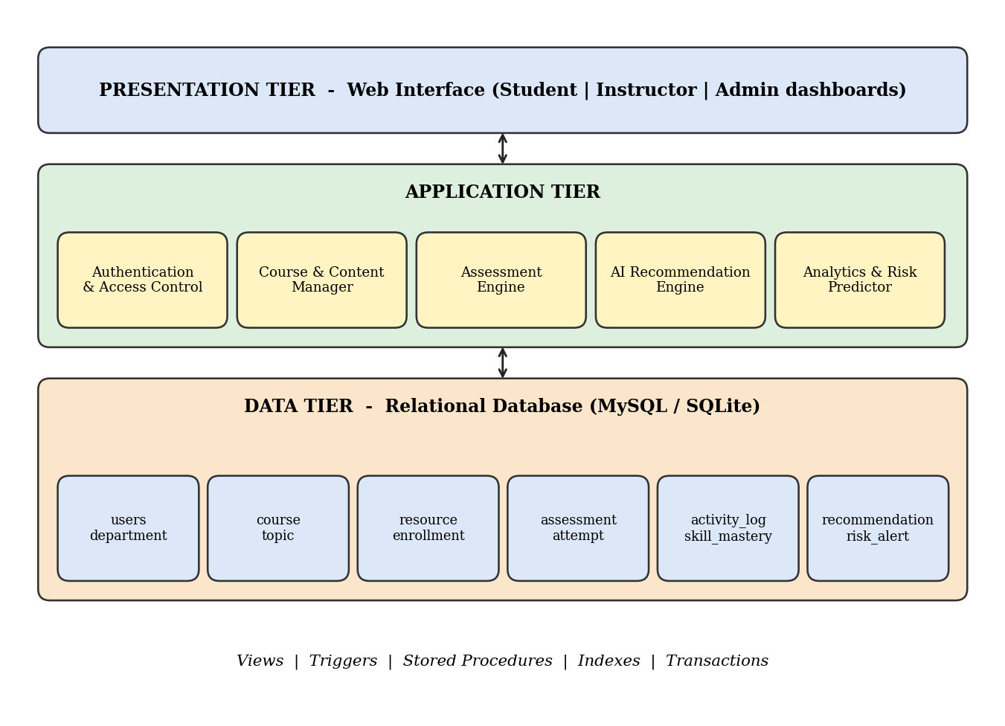
Figure 1: Three-tier architecture of the proposed AI-Driven LMS

2.7 Feasibility Study
A feasibility study was carried out before development to confirm that the project could be completed with the resources and time available to the team.
Table 2: Feasibility analysis
Type | Assessment
Technical | All required technology (relational database, SQL, a simple web or console front end) is freely available and covered in the DBMS course. The AI logic needs only aggregate queries and CASE expressions, so no specialised hardware or libraries are required.
Economic | The project uses open-source software (SQLite / MySQL, Python and standard web technologies). There is no licence cost; the only cost is the time of the four team members.
Operational | Students, instructors and administrators already use LMS products, so the interaction model is familiar. Dashboards and recommendations require no special training.
Schedule | The work was divided into analysis, design, implementation, testing and documentation phases, which fit within one academic term.
Legal / ethical | Only synthetic sample data is used. Real deployments must protect student privacy, restrict access by role and explain the use of analytics to learners.

3. Methodology

3.1 Development Approach
The project followed an iterative waterfall approach adapted to database development. The team first gathered requirements, then built conceptual, logical and physical designs in sequence, and finally implemented, tested and documented the system. Short feedback loops were used between design and implementation: whenever a query or test revealed a weakness in the schema, the design was revised and the affected tables were recreated. Table 3 lists the phases and their outputs.
Table 3: Project phases and deliverables
Phase | Activities | Deliverable
1. Requirement analysis | Identify users, data and functions; study existing LMS products | Requirement list, use cases
2. Conceptual design | Identify entities, attributes, relationships and cardinalities | ER diagram
3. Logical design | Map ER model to relations; normalise to 3NF/BCNF | Relational schema, data dictionary
4. Physical design | Choose data types, constraints, indexes | DDL script
5. Implementation | Create tables, load sample data, write queries, views, triggers, procedures | SQL scripts, populated database
6. AI feature development | Mastery calculation, recommendation scoring, risk classification | Trigger, view and INSERT...SELECT logic
7. Testing | Constraint tests, query verification, performance tests | Test report
8. Documentation | Compile report and user guide | This document

3.2 Requirement Analysis

3.2.1 Functional Requirements
Table 4: Functional requirements
ID | Requirement | User
FR1 | The system shall register users with a role (student, instructor or administrator) and a unique e-mail address. | Admin
FR2 | The system shall allow instructors to create courses, topics, resources and assessments. | Instructor
FR3 | The system shall allow students to enrol in courses; a student shall not enrol twice in the same course. | Student
FR4 | The system shall record every attempt at an assessment with marks and date. | Student
FR5 | The system shall record the time a student spends on each resource. | Student
FR6 | The system shall automatically update the mastery percentage of a topic after each attempt. | System
FR7 | The system shall identify weak topics (mastery below 50 per cent) for each student. | System
FR8 | The system shall recommend learning resources for weak topics and rank them by a score. | System
FR9 | The system shall raise a HIGH risk alert when an attempt scores below 40 per cent. | System
FR10 | The system shall provide dashboards of course and topic performance to instructors. | Instructor
FR11 | The system shall allow administrators to manage departments and users and to produce reports. | Admin

3.2.2 Non-Functional Requirements
- Integrity: primary keys, foreign keys, unique and check constraints must prevent invalid data.
- Performance: frequently used lookups (by student, by course) must use indexes so that response time remains low as data grows.
- Security: role-based access, hashed passwords in a real deployment, and least-privilege database accounts.
- Consistency: multi-step updates must run inside transactions so that either all steps succeed or none do.
- Usability: dashboards must present information in a clear and simple form.
- Maintainability: the schema must be normalised and documented with a data dictionary.
- Portability: the SQL used is standard so that it runs on MySQL, PostgreSQL or SQLite with minor syntax changes.

3.2.3 Hardware and Software Requirements
Table 5: Hardware and software requirements
Category | Requirement
Processor | Intel Core i3 or equivalent and above
RAM | 4 GB minimum (8 GB recommended)
Storage | 500 MB free disk space
Operating system | Windows 10/11, Linux or macOS
Database engine | SQLite 3 (tested); MySQL 8 / PostgreSQL 14 (deployment)
Languages | SQL, Python 3 for scripting and charts
Tools | DB Browser for SQLite / MySQL Workbench, VS Code, Draw.io, Microsoft Word
Browser | Any modern browser for the web front end

3.3 System Architecture
The system follows the classic three-tier architecture shown in Figure 1. The presentation tier consists of the dashboards for students, instructors and administrators. The application tier contains five logical components: authentication and access control, course and content management, the assessment engine, the AI recommendation engine and the analytics and risk predictor. The data tier is the relational database with its tables, views, triggers, procedures and indexes. Keeping the intelligence close to the data tier ensures that every application, whether a web page, a mobile app or a report generator, sees exactly the same recommendations and alerts.

3.4 Module Description

3.4.1 User and Access Management Module
This module manages the users and department tables. Every user has a role that decides which functions are available. Registration enforces unique e-mail addresses and valid roles through constraints. Departments group users and courses and are used for institutional reports.

3.4.2 Course and Content Module
Instructors create courses, divide each course into topics with a difficulty rating from 1 (easy) to 5 (hard) and attach learning resources of four types: video, PDF, quiz and lab. The difficulty rating of the topic is later used by the recommendation score. Enrolment of students is recorded in the enrollment table, which resolves the many-to-many relationship between students and courses.

3.4.3 Assessment Module
Each topic has one or more assessments with a maximum mark. Every student attempt is stored in the attempt table with the marks obtained and the date. A check constraint guarantees that marks are never negative. The module is the main source of evidence for the AI features.

3.4.4 Activity Tracking Module
The activity_log table records the minutes a student spent on each resource on a given date. Engagement indicators such as total learning time, resource-type preference and inactivity periods are derived from this table. It is the largest table in a real deployment, so it is indexed on the student identifier and date.

3.4.5 AI Mastery, Recommendation and Risk Module
This module owns the tables skill_mastery, recommendation and risk_alert. The mastery table stores one row per student and topic. The recommendation table stores the ranked resources suggested for each student together with a human-readable reason. The risk table records alerts raised for instructors. These tables are filled automatically by triggers and by the recommendation procedure described in Chapter 4.

3.4.6 Reporting and Dashboard Module
Views such as v_student_performance and v_weak_topics hide complex joins and give each dashboard a simple data source. Instructors see class averages and at-risk learners, students see their weak topics and recommended resources, and administrators see enrolment statistics and resource usage.

3.5 AI Techniques Used
The AI features are implemented with transparent, explainable techniques that run entirely inside the database. This choice keeps the logic auditable and fits the objectives of the DBMS course.

3.5.1 Topic Mastery Estimation
For each student and topic the mastery percentage is derived from the most recent assessment attempt:
Mastery (%) = (marks obtained / maximum marks) × 100
When a new attempt is inserted, the trigger trg_attempt_mastery replaces the stored mastery value with the new percentage. A topic is regarded as weak when its mastery is below 50 per cent, developing between 50 and 75 per cent, and strong above 75 per cent.

3.5.2 Resource Recommendation Score
For every weak topic the system selects video and lab resources attached to that topic and assigns each a score:
Score = (100 − Mastery) × 1 / (1 + |Difficulty − 3|)
The first factor is the knowledge gap: the lower the mastery, the larger the score. The second factor reduces the score of topics whose difficulty is far from the medium level 3, because very easy or very hard material is less suitable as an immediate next step for a struggling learner. Resources are shown to the student in descending order of score, and the reason text, for example “Weak topic: Normalization”, explains every suggestion.

3.5.3 Risk Classification
Learners are classified by their average score percentage across all attempts: HIGH risk below 45 per cent, MEDIUM between 45 and 65 per cent and LOW at 65 per cent or above. In addition, the trigger trg_low_score_alert inserts a HIGH alert immediately whenever a single attempt scores below 40 per cent. Total learning time from the activity log is reported next to the risk class so that the instructor can see whether a low score is accompanied by low or high engagement.
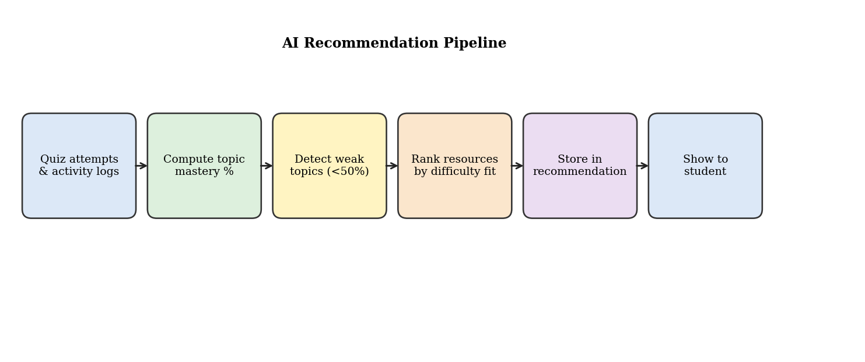
Figure 2: AI recommendation pipeline

3.6 Use Case Model
Figure 3 shows the use cases of the three actors. The student can register or log in, enrol in courses, view resources, attempt quizzes and view personalised recommendations. The instructor can create courses, upload resources, create assessments and view class analytics. The administrator can manage users and generate institutional reports.
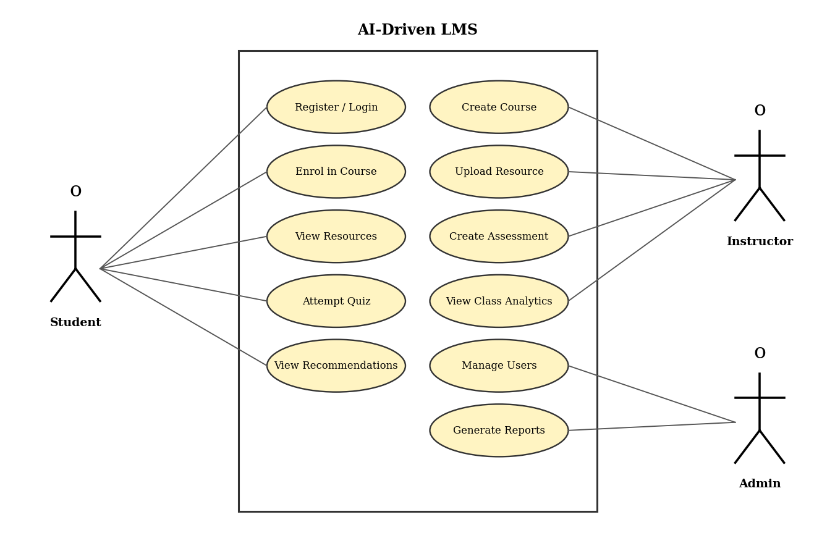
Figure 3: Use case diagram of the AI-Driven LMS

3.7 Data Flow Diagrams
The context diagram in Figure 4 shows the system as a single process that exchanges data with three external entities (student, instructor and administrator) and one data store. Figure 5 expands the system into six processes: authentication, course management, activity tracking, assessment, AI recommendation, and risk and reports. The data stores correspond to groups of tables in the database.
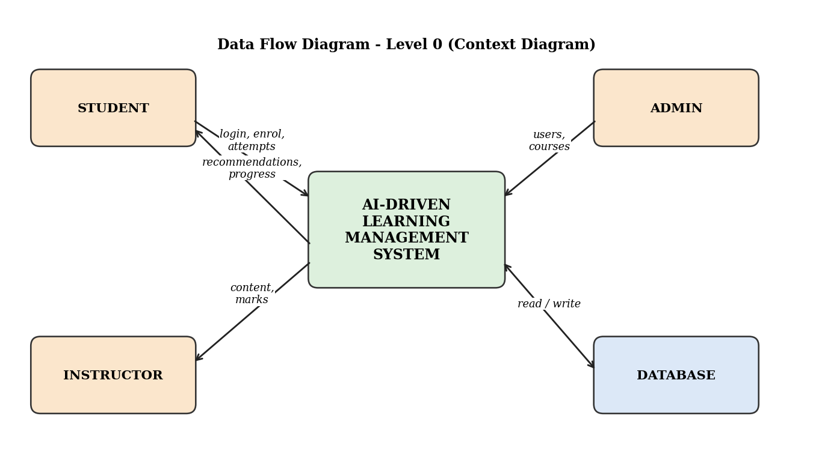
Figure 4: Data Flow Diagram, Level 0 (context diagram)
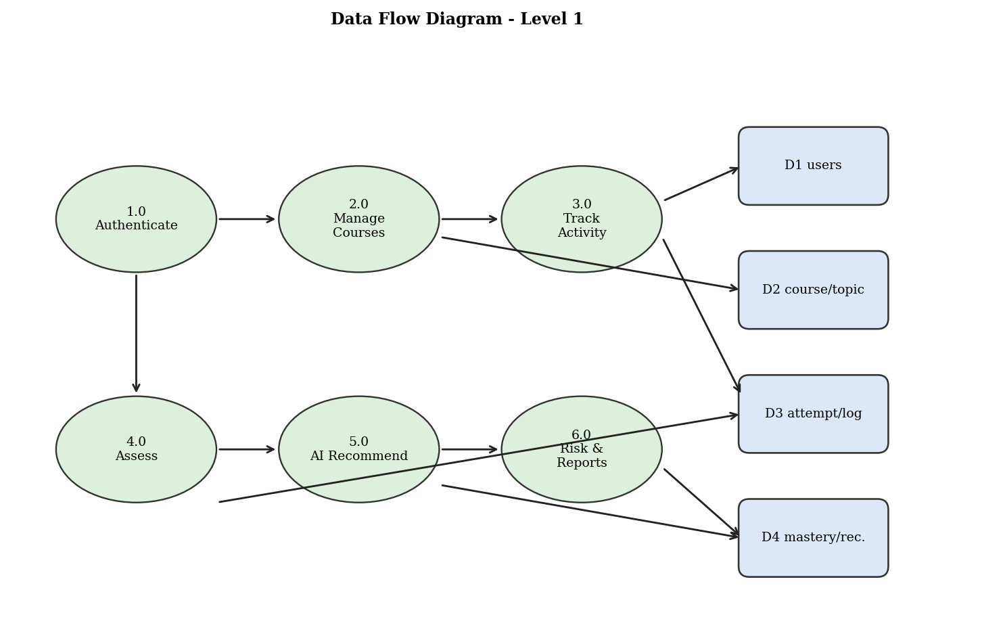
Figure 5: Data Flow Diagram, Level 1

3.8 Entity-Relationship Design

3.8.1 Entities and Attributes
The analysis of the requirements produced the entities listed in Table 6. Each entity has a primary key, which is underlined in the ER notation and marked PK here.
Table 6: Entities and their attributes
Entity | Attributes
DEPARTMENT | dept_id (PK), dept_name
USERS | user_id (PK), full_name, email, role, dept_id (FK), created_on
COURSE | course_id (PK), course_code, title, level, instructor_id (FK), dept_id (FK)
TOPIC | topic_id (PK), course_id (FK), topic_name, difficulty
RESOURCE | resource_id (PK), topic_id (FK), title, res_type, duration_min
ENROLLMENT | enroll_id (PK), student_id (FK), course_id (FK), enroll_date, status
ASSESSMENT | assess_id (PK), topic_id (FK), title, max_marks
ATTEMPT | attempt_id (PK), assess_id (FK), student_id (FK), marks, attempt_date
ACTIVITY_LOG | log_id (PK), student_id (FK), resource_id (FK), minutes_spent, log_date
SKILL_MASTERY | student_id (PK, FK), topic_id (PK, FK), mastery_pct, updated_on
RECOMMENDATION | rec_id (PK), student_id (FK), resource_id (FK), score, reason, created_on
RISK_ALERT | alert_id (PK), student_id (FK), course_id (FK), risk_level, raised_on

3.8.2 Relationships and Cardinalities
Table 7: Relationships between entities
Relationship | Entities | Cardinality | Explanation
has | DEPARTMENT – USERS | 1 : N | A department has many users; each user belongs to one department.
offers | DEPARTMENT – COURSE | 1 : N | A department offers many courses.
teaches | USERS (instructor) – COURSE | 1 : N | An instructor teaches many courses; a course has one instructor.
contains | COURSE – TOPIC | 1 : N | A course contains many topics.
has | TOPIC – RESOURCE | 1 : N | A topic has many learning resources.
assessed by | TOPIC – ASSESSMENT | 1 : N | A topic has one or more assessments.
enrols in | USERS (student) – COURSE | M : N | Resolved through ENROLLMENT.
makes | USERS – ATTEMPT | 1 : N | A student makes many attempts.
taken in | ASSESSMENT – ATTEMPT | 1 : N | An assessment is attempted many times.
generates | USERS – ACTIVITY_LOG | 1 : N | A student generates many activity records.
recommended | USERS – RESOURCE | M : N | Resolved through RECOMMENDATION.
mastery of | USERS – TOPIC | M : N | Resolved through SKILL_MASTERY.

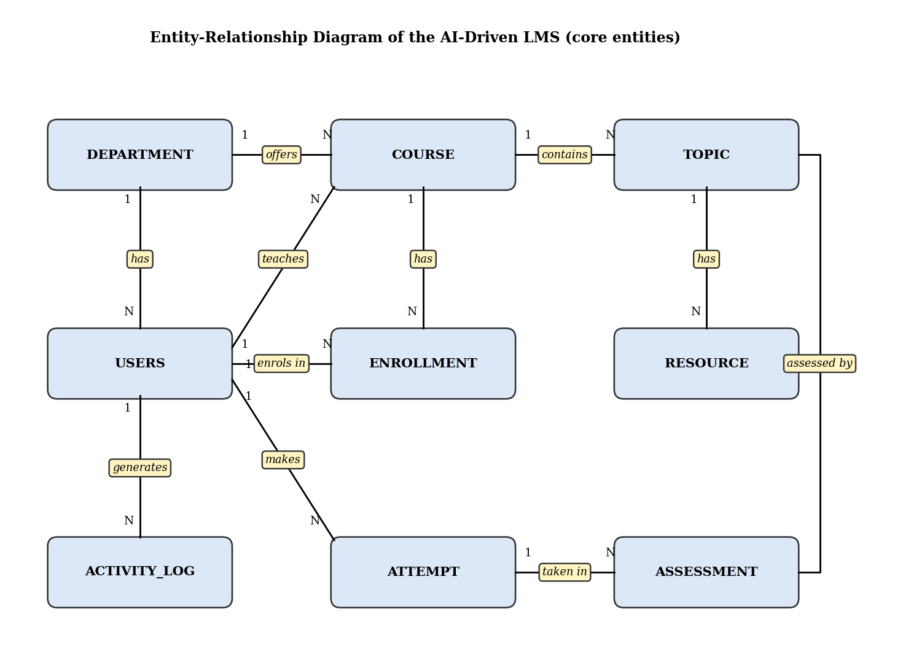
Figure 6: Entity-Relationship diagram of the AI-Driven LMS

3.9 Relational Schema
The ER model was mapped to the relational model by applying the standard rules: every strong entity became a table, every one-to-many relationship was implemented as a foreign key on the many side, and every many-to-many relationship (enrolment, recommendation, mastery) became a table of its own. Figure 7 shows the resulting schema with primary keys and foreign keys.
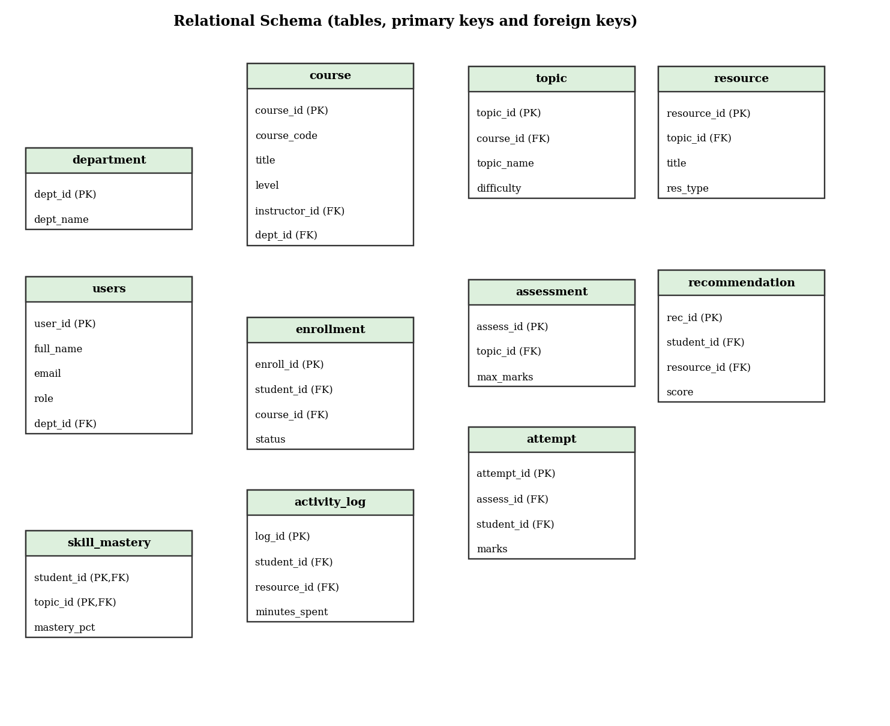
Figure 7: Relational schema with primary and foreign keys

3.10 Normalization
Normalisation removes redundancy and prevents insertion, update and deletion anomalies. The design was developed by starting from a single wide “learning record” relation and refining it step by step, as in Figure 8.
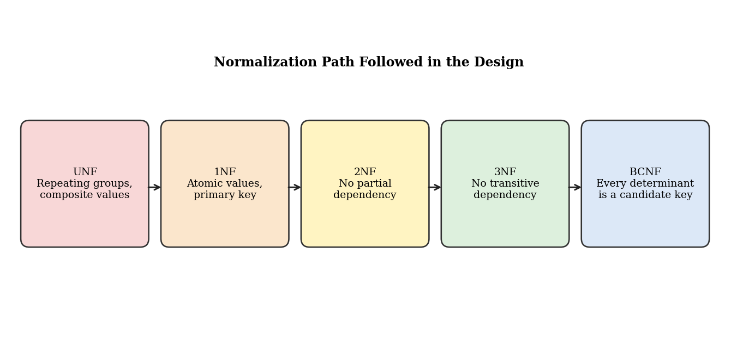
Figure 8: Normalisation path followed in the design
Unnormalised form (UNF). The starting relation LearningRecord(student_id, student_name, email, dept_name, course_code, course_title, instructor_name, topic_name, resource_title, quiz_marks, minutes_spent) repeats student, course and instructor details for every resource and every attempt. A change of instructor name would require updating many rows.
First normal form (1NF). All attributes were made atomic and repeating groups (several topics, several resources) were converted into separate rows. A primary key was chosen for each relation.
Second normal form (2NF). In the relation with composite key (student_id, course_code, topic_name) the attributes student_name and email depend only on student_id, and course_title depends only on course_code. These partial dependencies were removed by creating the relations USERS, COURSE and TOPIC.
Third normal form (3NF). A transitive dependency existed: student_id → dept_id → dept_name, and course_id → instructor_id → instructor_name. The relation DEPARTMENT was created and instructor details were kept only in USERS, referenced by a foreign key in COURSE.
Boyce-Codd normal form (BCNF). For every relation, each non-trivial functional dependency has a candidate key on its left side. For example, in ENROLLMENT the dependency (student_id, course_id) → status is valid with a candidate key as determinant, and email → user_id in USERS is valid because email is a unique candidate key. Hence all relations satisfy BCNF.
Table 8: Sample functional dependencies
Relation | Functional dependency | Normal form
USERS | user_id → full_name, email, role, dept_id, created_on | BCNF
USERS | email → user_id | BCNF (candidate key)
COURSE | course_id → course_code, title, level, instructor_id, dept_id | BCNF
TOPIC | topic_id → course_id, topic_name, difficulty | BCNF
ENROLLMENT | (student_id, course_id) → enroll_date, status | BCNF
SKILL_MASTERY | (student_id, topic_id) → mastery_pct, updated_on | BCNF
ATTEMPT | attempt_id → assess_id, student_id, marks, attempt_date | BCNF

3.11 Data Dictionary
The data dictionary below documents every table of the database. Data types follow standard SQL and are valid in MySQL with minor changes (for example, AUTO_INCREMENT for key columns).
Table 9: Data dictionary: DEPARTMENT
Column | Data type | Constraint | Description
dept_id | INTEGER | PRIMARY KEY | Unique department identifier
dept_name | VARCHAR(60) | NOT NULL, UNIQUE | Name of the department

Table 10: Data dictionary: USERS
Column | Data type | Constraint | Description
user_id | INTEGER | PRIMARY KEY | Unique user identifier
full_name | VARCHAR(80) | NOT NULL | Full name
email | VARCHAR(100) | NOT NULL, UNIQUE | Login e-mail address
role | VARCHAR(12) | NOT NULL, CHECK in (STUDENT, INSTRUCTOR, ADMIN) | User role
dept_id | INTEGER | FOREIGN KEY → department | Department of the user
created_on | DATE | NOT NULL | Registration date

Table 11: Data dictionary: COURSE
Column | Data type | Constraint | Description
course_id | INTEGER | PRIMARY KEY | Unique course identifier
course_code | VARCHAR(10) | NOT NULL, UNIQUE | Short code such as DBMS101
title | VARCHAR(100) | NOT NULL | Course title
level | VARCHAR(12) | NOT NULL, CHECK | BEGINNER, INTERMEDIATE or ADVANCED
instructor_id | INTEGER | NOT NULL, FK → users | Instructor in charge
dept_id | INTEGER | NOT NULL, FK → department | Offering department

Table 12: Data dictionary: TOPIC and RESOURCE
Column | Data type | Constraint | Description
topic_id | INTEGER | PRIMARY KEY | Unique topic identifier
course_id | INTEGER | NOT NULL, FK → course | Parent course
topic_name | VARCHAR(80) | NOT NULL | Topic title
difficulty | INTEGER | NOT NULL, CHECK 1 to 5 | Difficulty rating
resource_id | INTEGER | PRIMARY KEY (resource) | Unique resource identifier
res_type | VARCHAR(10) | CHECK in (VIDEO, PDF, QUIZ, LAB) | Resource type
duration_min | INTEGER | NOT NULL | Expected study time in minutes

Table 13: Data dictionary: ENROLLMENT, ASSESSMENT and ATTEMPT
Column | Data type | Constraint | Description
enroll_id | INTEGER | PRIMARY KEY | Enrolment identifier
status | VARCHAR(10) | DEFAULT ACTIVE, CHECK | ACTIVE, COMPLETED or DROPPED
(student_id, course_id) | — | UNIQUE | A student enrols once per course
assess_id | INTEGER | PRIMARY KEY (assessment) | Assessment identifier
max_marks | INTEGER | NOT NULL, CHECK > 0 | Maximum marks
attempt_id | INTEGER | PRIMARY KEY (attempt) | Attempt identifier
marks | INTEGER | NOT NULL, CHECK ≥ 0 | Marks obtained
attempt_date | DATE | NOT NULL | Date of attempt

Table 14: Data dictionary: ACTIVITY_LOG and SKILL_MASTERY
Column | Data type | Constraint | Description
log_id | INTEGER | PRIMARY KEY | Log identifier
student_id | INTEGER | NOT NULL, FK → users | Student who studied
resource_id | INTEGER | NOT NULL, FK → resource | Resource studied
minutes_spent | INTEGER | NOT NULL | Time spent in minutes
log_date | DATE | NOT NULL | Date of activity
mastery_pct | DECIMAL(5,2) | NOT NULL | Mastery of the topic in per cent
(student_id, topic_id) | — | PRIMARY KEY (skill_mastery) | One mastery value per student and topic

Table 15: Data dictionary: RECOMMENDATION and RISK_ALERT
Column | Data type | Constraint | Description
rec_id | INTEGER | PRIMARY KEY | Recommendation identifier
score | DECIMAL(5,2) | NOT NULL | Ranking score of the suggestion
reason | VARCHAR(120) | — | Explanation shown to the student
created_on | DATE | NOT NULL | Date generated
alert_id | INTEGER | PRIMARY KEY (risk_alert) | Alert identifier
risk_level | VARCHAR(8) | NOT NULL, CHECK | LOW, MEDIUM or HIGH
raised_on | DATE | NOT NULL | Date the alert was raised

3.12 Integrity Constraints
Integrity is enforced by the database itself, not by the application, so that no program can bypass the rules. Entity integrity is guaranteed by primary keys; referential integrity by foreign keys, which prevent orphan rows and block deletion of parent rows that are still referenced; domain integrity by CHECK constraints on roles, levels, resource types, difficulty and marks; and uniqueness by UNIQUE constraints on e-mail, course code and the pair (student, course). Chapter 5 shows these rules rejecting invalid statements.

3.13 Security Design
- Role-based access: the application shows functions according to the role column; database accounts are created per role, with students limited to read access on their own views.
- Least privilege: administrators alone can modify the users and department tables; instructors can write to course, topic, resource and assessment tables; students can only insert attempts and activity logs.
- Password protection: in a production deployment, passwords must be stored as salted hashes (for example bcrypt) in a separate credentials table; they are not part of the sample database.
- SQL-injection prevention: all queries issued by the front end must use parameterised statements.
- Auditability: timestamps such as created_on, attempt_date and raised_on allow every change to be traced.
- Backup: regular dumps and write-ahead logging allow recovery after failure.

4. Experiments (Implementation)
This chapter describes how the design of Chapter 3 was turned into a working database. All statements shown here were executed on the sample database, and the outputs reported in Chapter 5 were produced by those executions. The main SQL dialect is standard SQL as supported by SQLite 3; the places where MySQL syntax differs are indicated.

4.1 Experimental Setup
Table 16: Experimental environment
Item | Details
Database engine | SQLite 3 (execution of all scripts); MySQL 8.0 syntax shown for procedures
Client tools | SQLite command line, Python 3 sqlite3 module, DB Browser for SQLite
Scripting and charts | Python 3 with Matplotlib for charts and diagrams
Test data | Synthetic: 13 users, 3 courses, 8 topics, 24 resources, 20 enrolments, 61 attempts, 131 activity records
Performance test data | 200,000 synthetic activity records for 2,000 students
Constraint checking | Foreign key enforcement switched on (PRAGMA foreign_keys = ON)

4.2 Creating the Database Schema
The physical design translates each relation into a CREATE TABLE statement. Keys and integrity rules are declared inside the table definition so that the database enforces them. The complete DDL script is given below; it creates the twelve tables of the schema and the three indexes used for performance.
CREATE TABLE department (
dept_id INTEGER PRIMARY KEY,
dept_name VARCHAR(60) NOT NULL UNIQUE
);

CREATE TABLE users (
user_id INTEGER PRIMARY KEY,
full_name VARCHAR(80) NOT NULL,
email VARCHAR(100) NOT NULL UNIQUE,
role VARCHAR(12) NOT NULL CHECK(role IN ('STUDENT','INSTRUCTOR','ADMIN')),
dept_id INTEGER,
created_on DATE NOT NULL,
FOREIGN KEY(dept_id) REFERENCES department(dept_id)
);

CREATE TABLE course (
course_id INTEGER PRIMARY KEY,
course_code VARCHAR(10) NOT NULL UNIQUE,
title VARCHAR(100) NOT NULL,
level VARCHAR(12) NOT NULL CHECK(level IN ('BEGINNER','INTERMEDIATE','ADVANCED')),
instructor_id INTEGER NOT NULL,
dept_id INTEGER NOT NULL,
FOREIGN KEY(instructor_id) REFERENCES users(user_id),
FOREIGN KEY(dept_id) REFERENCES department(dept_id)
);

CREATE TABLE topic (
topic_id INTEGER PRIMARY KEY,
course_id INTEGER NOT NULL,
topic_name VARCHAR(80) NOT NULL,
difficulty INTEGER NOT NULL CHECK(difficulty BETWEEN 1 AND 5),
FOREIGN KEY(course_id) REFERENCES course(course_id)
);

CREATE TABLE resource (
resource_id INTEGER PRIMARY KEY,
topic_id INTEGER NOT NULL,
title VARCHAR(100) NOT NULL,
res_type VARCHAR(10) NOT NULL CHECK(res_type IN ('VIDEO','PDF','QUIZ','LAB')),
duration_min INTEGER NOT NULL,
FOREIGN KEY(topic_id) REFERENCES topic(topic_id)
);

CREATE TABLE enrollment (
enroll_id INTEGER PRIMARY KEY,
student_id INTEGER NOT NULL,
course_id INTEGER NOT NULL,
enroll_date DATE NOT NULL,
status VARCHAR(10) NOT NULL DEFAULT 'ACTIVE' CHECK(status IN ('ACTIVE','COMPLETED','DROPPED')),
UNIQUE(student_id,course_id),
FOREIGN KEY(student_id) REFERENCES users(user_id),
FOREIGN KEY(course_id) REFERENCES course(course_id)
);

CREATE TABLE assessment (
assess_id INTEGER PRIMARY KEY,
topic_id INTEGER NOT NULL,
title VARCHAR(80) NOT NULL,
max_marks INTEGER NOT NULL CHECK(max_marks>0),
FOREIGN KEY(topic_id) REFERENCES topic(topic_id)
);

CREATE TABLE attempt (
attempt_id INTEGER PRIMARY KEY,
assess_id INTEGER NOT NULL,
student_id INTEGER NOT NULL,
marks INTEGER NOT NULL CHECK(marks>=0),
attempt_date DATE NOT NULL,
FOREIGN KEY(assess_id) REFERENCES assessment(assess_id),
FOREIGN KEY(student_id) REFERENCES users(user_id)
);

CREATE TABLE activity_log (
log_id INTEGER PRIMARY KEY,
student_id INTEGER NOT NULL,
resource_id INTEGER NOT NULL,
minutes_spent INTEGER NOT NULL,
log_date DATE NOT NULL,
FOREIGN KEY(student_id) REFERENCES users(user_id),
FOREIGN KEY(resource_id) REFERENCES resource(resource_id)
);

CREATE TABLE skill_mastery (
student_id INTEGER NOT NULL,
topic_id INTEGER NOT NULL,
mastery_pct DECIMAL(5,2) NOT NULL,
updated_on DATE NOT NULL,
PRIMARY KEY(student_id,topic_id),
FOREIGN KEY(student_id) REFERENCES users(user_id),
FOREIGN KEY(topic_id) REFERENCES topic(topic_id)
);

CREATE TABLE recommendation (
rec_id INTEGER PRIMARY KEY,
student_id INTEGER NOT NULL,
resource_id INTEGER NOT NULL,
score DECIMAL(5,2) NOT NULL,
reason VARCHAR(120),
created_on DATE NOT NULL,
FOREIGN KEY(student_id) REFERENCES users(user_id),
FOREIGN KEY(resource_id) REFERENCES resource(resource_id)
);

CREATE TABLE risk_alert (
alert_id INTEGER PRIMARY KEY,
student_id INTEGER NOT NULL,
course_id INTEGER NOT NULL,
risk_level VARCHAR(8) NOT NULL CHECK(risk_level IN ('LOW','MEDIUM','HIGH')),
raised_on DATE NOT NULL,
FOREIGN KEY(student_id) REFERENCES users(user_id),
FOREIGN KEY(course_id) REFERENCES course(course_id)
);

CREATE INDEX idx_attempt_student ON attempt(student_id);
CREATE INDEX idx_activity_student ON activity_log(student_id, log_date);
CREATE INDEX idx_enroll_course ON enrollment(course_id);

Parent tables are created before child tables so that foreign key references are valid. Column sizes were chosen to be large enough for realistic values but small enough to keep indexes compact. When the script is deployed on MySQL, integer key columns may be declared with AUTO_INCREMENT and each table may be given the clause ENGINE=InnoDB so that foreign keys are enforced.

4.3 Loading Sample Data
A Python script generated realistic sample data with a fixed random seed so that the experiment can be repeated. The data includes three departments, three instructors and administrators, ten students (including the four members of the project team), three courses (Database Management Systems, Python Programming and Machine Learning Basics), eight topics, three resources (video, PDF and lab) per topic, enrolments, one quiz attempt per topic for each enrolled student and activity-log entries for the resources studied. Typical INSERT statements are shown below.
INSERT INTO department VALUES (1,'Computer Science and Engineering');
INSERT INTO users VALUES (1,'Dr. Meera Nair','meera.nair@klh.edu','INSTRUCTOR',1,'2025-06-01');
INSERT INTO users VALUES (4,'Rama Gayathri G','rama@klh.edu','STUDENT',1,'2025-07-01');
INSERT INTO course VALUES (1,'DBMS101','Database Management Systems','INTERMEDIATE',1,1);
INSERT INTO topic VALUES (2,1,'Normalization',3);
INSERT INTO resource VALUES (4,2,'Normalization - Video','VIDEO',25);
INSERT INTO assessment VALUES (2,2,'Normalization Quiz',20);

Table 17 to Table 20 show samples of the stored data as retrieved from the database.
Table 17: Sample rows of the USERS table
user_id | full_name | email | role | dept_id | created_on
1 | Dr. Meera Nair | meera.nair@klh.edu | INSTRUCTOR | 1 | 2025-06-01
2 | Prof. Arun Rao | arun.rao@klh.edu | INSTRUCTOR | 1 | 2025-06-01
3 | Admin Kiran | admin@klh.edu | ADMIN | 1 | 2025-06-01
4 | Rama Gayathri G | rama@klh.edu | STUDENT | 2 | 2025-07-01
5 | Chandana | chandana@klh.edu | STUDENT | 1 | 2025-07-02

Table 18: Sample rows of the COURSE table
course_id | course_code | title | level | instructor_id | dept_id
1 | DBMS101 | Database Management Systems | INTERMEDIATE | 1 | 1
2 | PY101 | Python Programming | BEGINNER | 2 | 1
3 | ML201 | Machine Learning Basics | ADVANCED | 2 | 2

Table 19: Sample rows of the TOPIC table
topic_id | course_id | topic_name | difficulty
1 | 1 | ER Modelling | 2
2 | 1 | Normalization | 3
3 | 1 | SQL Joins | 3
4 | 1 | Transactions | 4
5 | 2 | Loops and Functions | 1

Table 20: Sample rows of the ATTEMPT table
attempt_id | assess_id | student_id | marks | attempt_date
1 | 1 | 4 | 9 | 2025-09-14
2 | 2 | 4 | 4 | 2025-09-08
3 | 3 | 4 | 4 | 2025-09-18
4 | 4 | 4 | 9 | 2025-09-02
5 | 5 | 4 | 12 | 2025-09-08

4.4 SQL Queries
A set of queries was written to answer the typical questions of students, instructors and administrators. Each query is shown with its output in the order in which it was executed.

4.4.1 Enrolment Statistics
Query Q1 counts the students enrolled in each course using a LEFT JOIN so that courses with no enrolment still appear.
SELECT c.course_code, c.title, COUNT(e.enroll_id) AS enrolled
FROM course c
LEFT JOIN enrollment e ON c.course_id=e.course_id
GROUP BY c.course_id
ORDER BY enrolled DESC;

Table 21: Q1 output: enrolment count per course
course_code | title | enrolled
DBMS101 | Database Management Systems | 10
PY101 | Python Programming | 7
ML201 | Machine Learning Basics | 3

4.4.2 Student Performance
Query Q2 computes each student’s average percentage across all quiz attempts and lists the best five students.
SELECT u.full_name, ROUND(AVG(100.0*a.marks/s.max_marks),1) AS avg_pct
FROM attempt a
JOIN assessment s ON a.assess_id=s.assess_id
JOIN users u ON u.user_id=a.student_id
GROUP BY u.user_id
ORDER BY avg_pct DESC
LIMIT 5;

Table 22: Q2 output: top five students by average score
full_name | avg_pct
Harsha Vardhan | 79.2
Keerthi S | 77.5
Divya Reddy | 64.2
Chandana | 61.7
Srivalli | 58.3

4.4.3 Weak Topics of a Student
Query Q3 lists the topics in which student 4 (Rama Gayathri G) has mastery below 50 per cent.
SELECT t.topic_name, sm.mastery_pct
FROM skill_mastery sm
JOIN topic t ON t.topic_id=sm.topic_id
WHERE sm.student_id=4 AND sm.mastery_pct<50
ORDER BY sm.mastery_pct;

Table 23: Q3 output: weak topics for student 4
topic_name | mastery_pct
Normalization | 20
SQL Joins | 20
ER Modelling | 45
Transactions | 45

4.4.4 Topic-wise Class Average
Query Q4 aggregates mastery by topic to show which topics the whole class finds difficult, helping the instructor to plan revision.
SELECT t.topic_name, ROUND(AVG(sm.mastery_pct),1) AS class_avg
FROM skill_mastery sm
JOIN topic t ON t.topic_id=sm.topic_id
GROUP BY t.topic_id
ORDER BY class_avg;

Table 24: Q4 output: topic-wise class average mastery
topic_name | class_avg
Classification | 40
Regression | 55
Transactions | 55.5
Loops and Functions | 57.9
Normalization | 58.5
Data Structures | 60
SQL Joins | 63
ER Modelling | 66

4.4.5 Learning Time
Query Q5 sums the minutes spent by each student on resources, a simple engagement indicator.
SELECT u.full_name, SUM(l.minutes_spent) AS total_min
FROM activity_log l
JOIN users u ON u.user_id=l.student_id
GROUP BY u.user_id
ORDER BY total_min DESC
LIMIT 5;

Table 25: Q5 output: total learning time of the top five students
full_name | total_min
Manasa P | 281
Srivalli | 237
Harsha Vardhan | 216
Keerthi S | 206
Divya Reddy | 201

4.4.6 AI Recommendation Query
Query Q6 selects, for each DBMS101 student, the topic with the lowest mastery and recommends the video of that topic. A correlated sub-query finds the minimum mastery per student.
SELECT u.full_name, t.topic_name, sm.mastery_pct, r.title AS recommended_resource
FROM skill_mastery sm
JOIN users u ON u.user_id=sm.student_id
JOIN topic t ON t.topic_id=sm.topic_id
JOIN resource r ON r.topic_id=t.topic_id AND r.res_type='VIDEO'
WHERE t.course_id=1 AND sm.mastery_pct=(SELECT MIN(s2.mastery_pct)
FROM skill_mastery s2
JOIN topic t2 ON t2.topic_id=s2.topic_id
WHERE s2.student_id=sm.student_id AND t2.course_id=1)
ORDER BY sm.mastery_pct
LIMIT 6;

Table 26: Q6 output: weakest topic and recommended resource
full_name | topic_name | mastery_pct | recommended_resource
Rama Gayathri G | Normalization | 20 | Normalization - Video
Rama Gayathri G | SQL Joins | 20 | SQL Joins - Video
Srivalli | Transactions | 35 | Transactions - Video
Anil Kumar | ER Modelling | 35 | ER Modelling - Video
Chakrika | Normalization | 40 | Normalization - Video
Lokesh B | Normalization | 40 | Normalization - Video

4.4.7 Risk Classification Query
Query Q7 classifies students into HIGH, MEDIUM and LOW risk using a CASE expression over the average score and also reports the total minutes studied.
SELECT u.full_name, ROUND(AVG(100.0*a.marks/s.max_marks),1) AS avg_pct, (SELECT COALESCE(SUM(minutes_spent),0)
FROM activity_log l
WHERE l.student_id=u.user_id) AS minutes, CASE WHEN AVG(100.0*a.marks/s.max_marks)<45 THEN 'HIGH' WHEN AVG(100.0*a.marks/s.max_marks)<65 THEN 'MEDIUM' ELSE 'LOW' END AS risk
FROM attempt a
JOIN assessment s ON a.assess_id=s.assess_id
JOIN users u ON u.user_id=a.student_id
GROUP BY u.user_id
ORDER BY avg_pct
LIMIT 6;

Table 27: Q7 output: risk classification
full_name | avg_pct | minutes | risk
Manasa P | 44.2 | 281 | HIGH
Rama Gayathri G | 48.3 | 197 | MEDIUM
Chakrika | 50.8 | 185 | MEDIUM
Lokesh B | 52.5 | 130 | MEDIUM
Anil Kumar | 53.3 | 188 | MEDIUM
Srivalli | 58.3 | 237 | MEDIUM

4.4.8 Instructor Dashboard Query
Query Q8 summarises each course for the instructor: number of students who attempted quizzes, the average percentage and the highest mark.
SELECT c.course_code, COUNT(DISTINCT a.student_id) AS students, ROUND(AVG(100.0*a.marks/s.max_marks),1) AS avg_pct, MAX(a.marks) AS best_marks
FROM course c
JOIN topic t ON t.course_id=c.course_id
JOIN assessment s ON s.topic_id=t.topic_id
JOIN attempt a ON a.assess_id=s.assess_id
GROUP BY c.course_id;

Table 28: Q8 output: course performance summary
course_code | students | avg_pct | best_marks
DBMS101 | 10 | 60.8 | 20
PY101 | 7 | 58.9 | 20
ML201 | 3 | 47.5 | 12

4.4.9 Resource Usage
Query Q9 shows which resource types students use most, which guides instructors on what content to produce.
SELECT r.res_type, COUNT(*) AS views, SUM(l.minutes_spent) AS minutes
FROM activity_log l
JOIN resource r ON r.resource_id=l.resource_id
GROUP BY r.res_type
ORDER BY views DESC;

Table 29: Q9 output: usage by resource type
res_type | views | minutes
VIDEO | 47 | 667
PDF | 44 | 438
LAB | 40 | 872

4.5 Views
Views store complex queries under a name so that dashboards can use a simple SELECT. Two views were created.
CREATE VIEW v_student_performance AS
SELECT u.user_id, u.full_name, c.course_code,
ROUND(AVG(100.0*a.marks/s.max_marks),1) AS avg_pct,
COUNT(a.attempt_id) AS attempts
FROM attempt a
JOIN assessment s ON s.assess_id=a.assess_id
JOIN topic t ON t.topic_id=s.topic_id
JOIN course c ON c.course_id=t.course_id
JOIN users u ON u.user_id=a.student_id
GROUP BY u.user_id, c.course_id;

CREATE VIEW v_weak_topics AS
SELECT sm.student_id, t.topic_id, t.topic_name, sm.mastery_pct
FROM skill_mastery sm JOIN topic t ON t.topic_id=sm.topic_id
WHERE sm.mastery_pct < 50;

The view v_student_performance gives instructors a per-student, per-course summary, while v_weak_topics feeds the “weak topics” panel of the student dashboard and the recommendation procedure. Because views contain no stored data, they are always up to date.

4.6 Stored Procedure for Recommendation Generation
The recommendation logic is packaged as a stored procedure so that it can be scheduled nightly or called after each quiz. The procedure below uses MySQL syntax, since SQLite does not support stored procedures; the INSERT ... SELECT inside it was executed directly on the sample database.
DELIMITER //
CREATE PROCEDURE sp_generate_recommendations(IN p_date DATE)
BEGIN
START TRANSACTION;
DELETE FROM recommendation WHERE created_on < p_date;
INSERT INTO recommendation(student_id, resource_id, score, reason, created_on)
SELECT sm.student_id, r.resource_id,
ROUND((100 - sm.mastery_pct) * (1.0 / (1 + ABS(t.difficulty - 3))), 2),
CONCAT('Weak topic: ', t.topic_name), p_date
FROM skill_mastery sm
JOIN topic t ON t.topic_id = sm.topic_id
JOIN resource r ON r.topic_id = t.topic_id
AND r.res_type IN ('VIDEO','LAB')
WHERE sm.mastery_pct < 50;
COMMIT;
END //
DELIMITER ;

CALL sp_generate_recommendations('2025-10-06');

The procedure runs inside a transaction: the old recommendations are removed and the new ones inserted as one unit, so a student never sees an empty or half-updated recommendation list.

4.7 Triggers
Two AFTER INSERT triggers on the attempt table implement the real-time AI behaviour. The first keeps the mastery table synchronised; the second raises an alert for very low scores. The syntax shown is that of SQLite, which was used for testing; MySQL uses FOR EACH ROW and the keyword NEW in a very similar manner.
CREATE TRIGGER trg_attempt_mastery AFTER INSERT ON attempt
BEGIN
INSERT OR REPLACE INTO skill_mastery(student_id,topic_id,mastery_pct,updated_on)
SELECT NEW.student_id, s.topic_id,
ROUND(100.0*NEW.marks/s.max_marks,2), NEW.attempt_date
FROM assessment s WHERE s.assess_id = NEW.assess_id;
END;

CREATE TRIGGER trg_low_score_alert AFTER INSERT ON attempt
WHEN NEW.marks*100.0/(SELECT max_marks FROM assessment
WHERE assess_id=NEW.assess_id) < 40
BEGIN
INSERT INTO risk_alert(student_id,course_id,risk_level,raised_on)
SELECT NEW.student_id, t.course_id, 'HIGH', NEW.attempt_date
FROM assessment s JOIN topic t ON t.topic_id=s.topic_id
WHERE s.assess_id = NEW.assess_id;
END;

4.8 Indexing
Indexes speed up searches at the cost of some extra storage and slower inserts. Three indexes were created on the columns that appear most often in WHERE and JOIN clauses: attempt(student_id), activity_log(student_id, log_date) and enrollment(course_id). Primary keys and unique columns are indexed automatically by the database. The effect of an index on a large table is measured in Chapter 5.

4.9 Transactions and Concurrency
A transaction is a group of operations that must succeed or fail together (atomicity), that leaves the database valid (consistency), that is not disturbed by other transactions (isolation) and that survives failures once committed (durability). These ACID properties matter in an LMS because many students submit quizzes at the same moment. Enrolment of a student in a course, for example, is executed as follows.
BEGIN TRANSACTION;
INSERT INTO enrollment(enroll_id,student_id,course_id,enroll_date,status)
VALUES (21, 5, 2, '2025-10-07', 'ACTIVE');
INSERT INTO activity_log(log_id,student_id,resource_id,minutes_spent,log_date)
VALUES (900, 5, 13, 5, '2025-10-07');
COMMIT; -- use ROLLBACK; if either statement fails

If the second statement fails, for example because of a foreign key error, ROLLBACK undoes the enrolment as well. For concurrent access, the default isolation level (REPEATABLE READ in MySQL InnoDB, serialisable writes in SQLite) prevents dirty reads and lost updates. Row-level locking in InnoDB lets different students submit quizzes at the same time without blocking each other, while the UNIQUE constraint on (student_id, course_id) protects against double enrolment even if two requests arrive simultaneously.

4.10 Backup and Recovery
A backup strategy has three layers: a daily logical dump of the whole database (for example with mysqldump or the SQLite .dump command), continuous write-ahead or binary logging that allows point-in-time recovery, and weekly copies stored off-site. A restore test is performed after each change to the schema to confirm that the dump can rebuild the database from scratch.

4.11 User Interface Screens
The front end exposes the database through role-specific screens. Figures 9 to 11 show the login page, the student dashboard and the instructor dashboard. The student dashboard displays the number of courses, average mastery and weak topics, followed by the AI-recommended resources taken from the recommendation table. The instructor dashboard shows class size, average score, the number of at-risk students and a bar chart of topic performance obtained from the views.
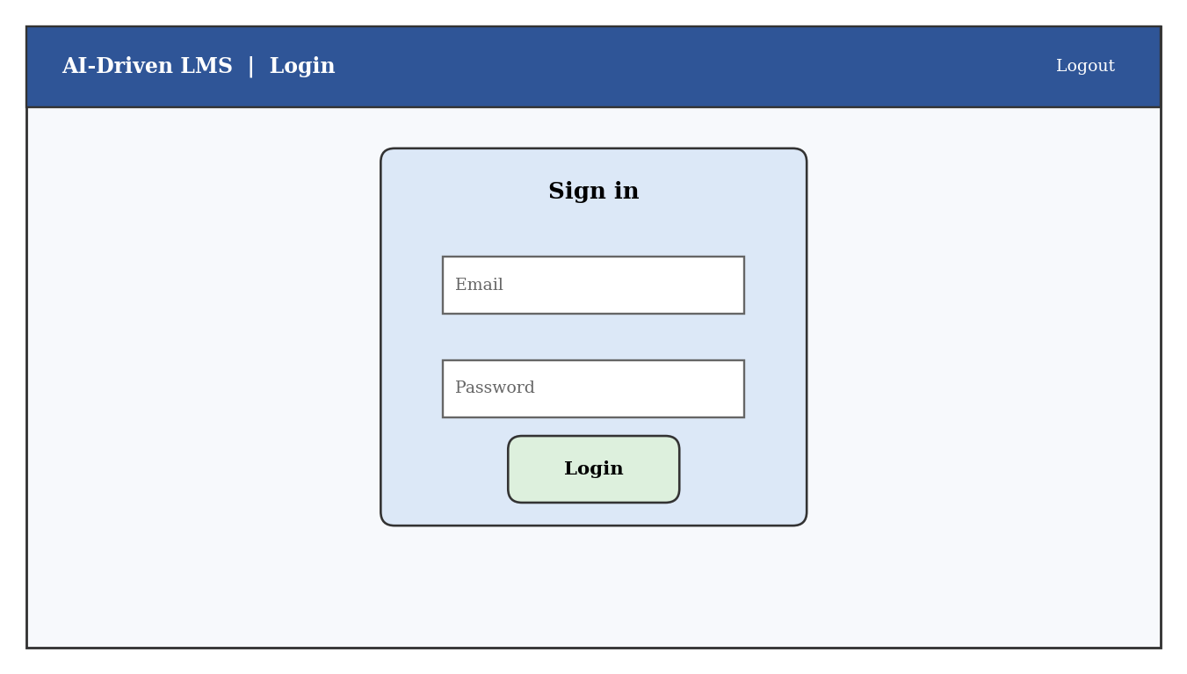
Figure 9: Login screen
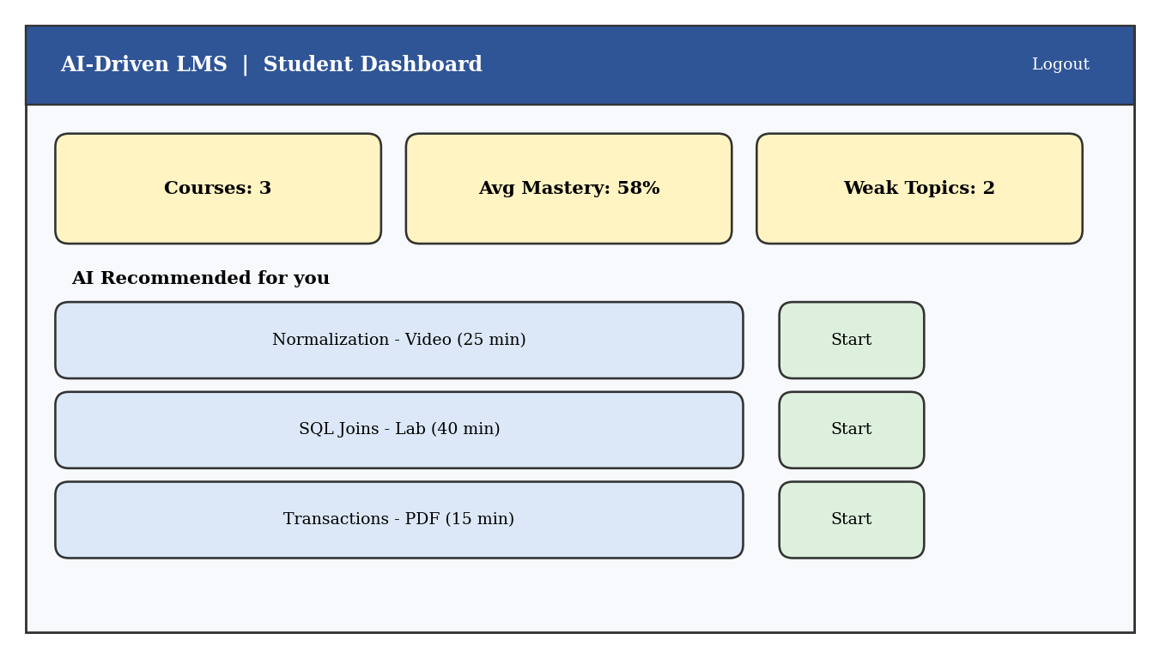
Figure 10: Student dashboard with AI-recommended resources
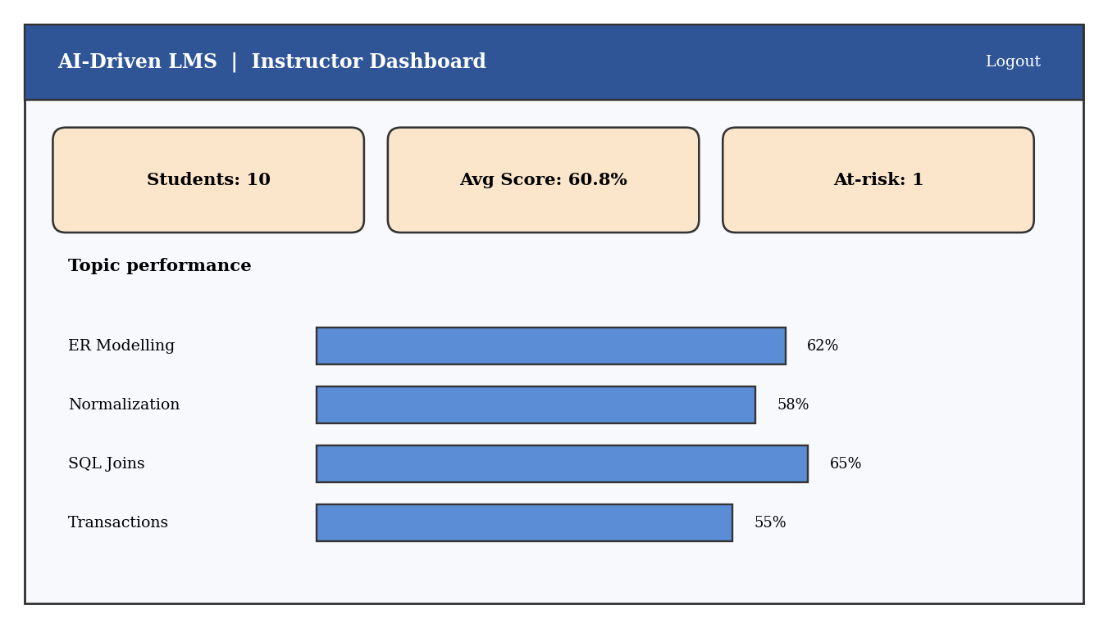
Figure 11: Instructor dashboard with topic performance

4.12 Testing Plan
Testing covered three areas. Constraint testing attempted to insert invalid data to confirm that the database rejects it. Functional testing verified that queries, views and triggers return the expected results. Performance testing measured the effect of an index on a table with 200,000 rows. The test cases are listed in Table 30 and their outcomes are reported in Chapter 5.
Table 30: Test cases
ID | Test case | Expected result
T1 | Insert a user with an existing e-mail address | Rejected (UNIQUE)
T2 | Insert a user with role TEACHER | Rejected (CHECK)
T3 | Insert a user with a non-existent department | Rejected (FOREIGN KEY)
T4 | Enrol the same student twice in one course | Rejected (UNIQUE pair)
T5 | Insert an attempt with negative marks | Rejected (CHECK)
T6 | Insert a topic with difficulty 9 | Rejected (CHECK)
T7 | Delete a course that still has topics | Rejected (FOREIGN KEY)
T8 | Insert a low-scoring attempt | Mastery updated and HIGH alert created (triggers)
T9 | Run the recommendation statement | Resources inserted for all weak topics
T10 | Query a 200,000-row table with and without an index | Index search faster than full scan

5. Results
This chapter reports the results obtained by executing the scripts and queries described in Chapter 4 on the sample database. All numbers are taken directly from the database outputs. Because the sample data is synthetic, the figures demonstrate that the system works correctly; they are not claims about real learners.

5.1 Database Statistics
Table 31 shows the number of rows in each table after the sample data was loaded and the triggers and recommendation statement had been executed. The recommendation table contains 34 rows generated automatically, and the risk_alert table contains the single alert raised by the trigger test.
Table 31: Row counts of the database tables
Table | Rows | Table | Rows
department | 3 | attempt | 61
users | 13 | activity_log | 131
course | 3 | skill_mastery | 60
topic | 8 | recommendation | 34
resource | 24 | risk_alert | 1
enrollment | 20 | assessment | 8

5.2 Results of the Analytical Queries
The enrolment query (Q1) shows that DBMS101 is the most popular course, with ten of the ten students enrolled, followed by Python Programming with seven and Machine Learning Basics with three. Query Q2 shows that Harsha Vardhan and Keerthi S have the highest average quiz percentages (79.2 and 77.5 per cent). Query Q5 shows that Manasa P spent the longest time on resources (281 minutes) while Query Q7 nevertheless classes her as HIGH risk because her average score is 44.2 per cent. This is an interesting case: high effort with low results suggests that the learner is working hard but with ineffective material, so an instructor should recommend a different kind of resource rather than simply urging more study.
Query Q4 identifies the topics that are hardest for the class. Classification in Machine Learning Basics has the lowest mean mastery (40.0 per cent), followed by Regression (55.0) and Transactions in DBMS (55.5). Query Q8 shows that DBMS101 has an average score of 60.8 per cent, Python Programming 58.9 per cent and Machine Learning Basics 47.5 per cent, which tells the instructor that revision effort should be concentrated on the advanced machine learning course.
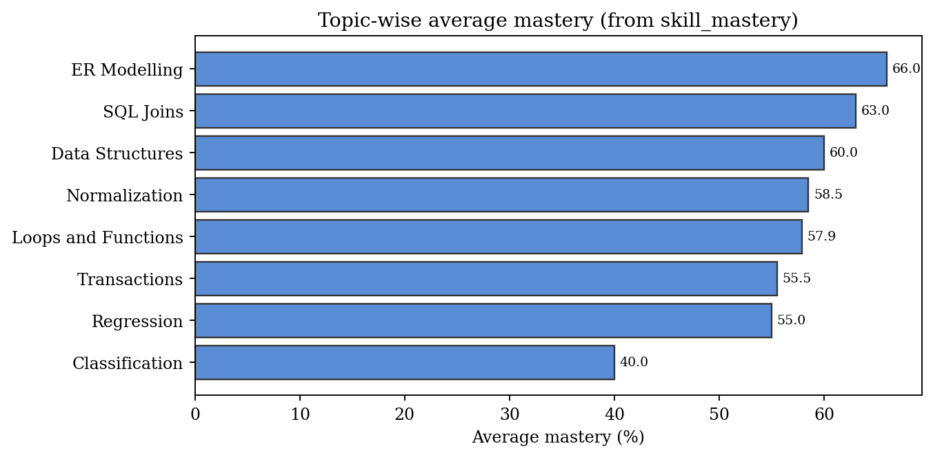
Figure 12: Topic-wise average mastery obtained from the skill_mastery table

5.3 Results of the Views
Table 32 shows the output of the view v_student_performance for DBMS101, ordered from the weakest to the strongest student. The weakest student, with an average of 32.5 per cent, is the first learner who would receive attention from the instructor.
Table 32: Output of v_student_performance for DBMS101 (five lowest averages)
user_id | full_name | course_code | avg_pct | attempts
4 | Rama Gayathri G | DBMS101 | 32.5 | 4
7 | Srivalli | DBMS101 | 46.3 | 4
12 | Lokesh B | DBMS101 | 50 | 4
8 | Anil Kumar | DBMS101 | 51.3 | 4
13 | Manasa P | DBMS101 | 52.5 | 4

Table 33 shows the output of v_weak_topics for student 4. All four topics of DBMS101 are below the 50 per cent threshold for this student, with Normalization and SQL Joins the weakest at 20 per cent.
Table 33: Output of v_weak_topics for student 4
student_id | topic_id | topic_name | mastery_pct
4 | 1 | ER Modelling | 45
4 | 2 | Normalization | 20
4 | 3 | SQL Joins | 20
4 | 4 | Transactions | 45

5.4 Trigger Results
Test T8 inserted a new attempt for student 7 (Srivalli) in the Transactions quiz with 6 marks out of 20. The trigger trg_attempt_mastery changed the stored mastery of this topic from 35 per cent to 30 per cent, and trg_low_score_alert inserted one HIGH-level row into risk_alert for the student and the course because 30 per cent is below the 40 per cent limit. No application code was needed; the database reacted to the insert by itself.
Table 34: Result of the trigger test (T8)
Item | Before the insert | After the insert
Mastery of Transactions for student 7 | 35 % | 30 %
Rows in risk_alert | 0 | 1 (student 7, HIGH)

5.5 Recommendation Results
Running the recommendation statement generated 34 recommendations for all students having at least one weak topic. Table 35 shows the five highest-ranked suggestions for student 4. The two weakest topics (Normalization and SQL Joins, both with mastery 20 per cent and medium difficulty 3) receive the highest score of 80, because the gap is large and the difficulty matches the medium level. ER Modelling, with mastery 45 per cent and difficulty 2, receives a lower score of 27.5, since its smaller gap is further reduced by the difficulty factor.
Table 35: Top recommendations for student 4
full_name | title | score | reason
Rama Gayathri G | Normalization - Lab | 80 | Weak topic: Normalization
Rama Gayathri G | Normalization - Video | 80 | Weak topic: Normalization
Rama Gayathri G | SQL Joins - Lab | 80 | Weak topic: SQL Joins
Rama Gayathri G | SQL Joins - Video | 80 | Weak topic: SQL Joins
Rama Gayathri G | ER Modelling - Lab | 27.5 | Weak topic: ER Modelling

Table 36 summarises the recommendation workload per student. Rama Gayathri G receives the largest number of suggestions (eight), because all four DBMS topics are weak, while Manasa P and Anil Kumar receive four each.
Table 36: Recommendation count and highest score per student
full_name | n_recs | top_score
Rama Gayathri G | 8 | 80
Chakrika | 6 | 60
Manasa P | 4 | 35
Lokesh B | 4 | 60
Anil Kumar | 4 | 32.5

5.6 Risk Classification Results
Figure 13 plots every student’s average score against the risk bands defined in Section 3.5.3. Students whose bar falls below the lower dashed line are HIGH risk, those between the lines are MEDIUM risk and the rest are LOW risk. The chart makes it easy for an instructor to see at a glance that most of the class lies in the medium band and that two students are comfortably in the low-risk zone.
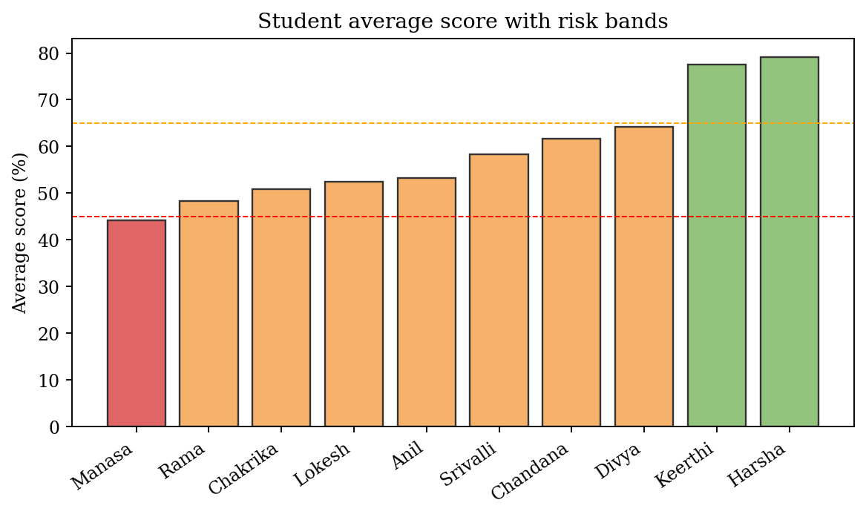
Figure 13: Student average scores with risk bands
Figure 14 shows how students divide their learning minutes between resource types. Lab sessions account for the largest share of time (872 minutes), videos follow (667 minutes), and PDFs account for the least (438 minutes), although PDFs were opened almost as often as videos (44 against 47 views). This suggests that students spend longer on practical labs but open readings only briefly, which supports recommending lab resources for weak topics.
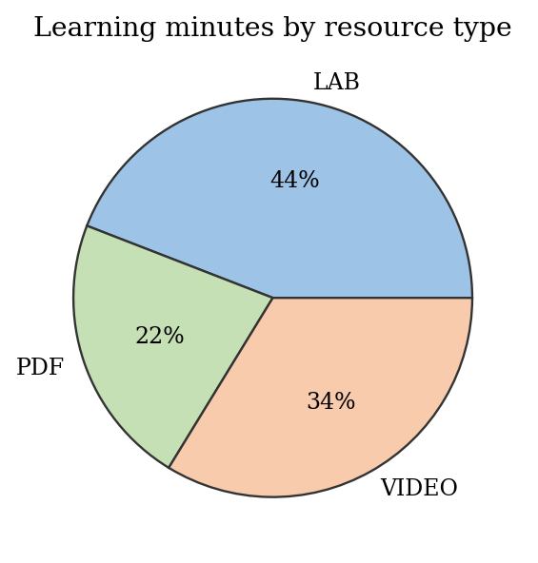
Figure 14: Share of learning minutes by resource type

5.7 Constraint Test Results
Every invalid statement in tests T1 to T7 was rejected by the database engine with an appropriate error, demonstrating that data integrity is enforced at the lowest level. The messages in Table 37 are the actual outputs of the SQLite engine.
Table 37: Results of constraint tests
ID | Test | Engine response
T1 | Duplicate e-mail address | Rejected: UNIQUE constraint failed: users.email
T2 | Invalid role | Rejected: CHECK constraint failed: role IN ('STUDENT','INSTRUCTOR','ADMIN')
T3 | Foreign key violation (no such department) | Rejected: FOREIGN KEY constraint failed
T4 | Duplicate enrolment | Rejected: UNIQUE constraint failed: enrollment.student_id, enrollment.course_id
T5 | Negative marks | Rejected: CHECK constraint failed: marks>=0
T6 | Difficulty out of range | Rejected: CHECK constraint failed: difficulty BETWEEN 1 AND 5
T7 | Delete course referenced by topics | Rejected: FOREIGN KEY constraint failed

5.8 Effect of Indexing
Test T10 compared the execution plan of a lookup by student before and after the index was created. Without the index the engine reports "SCAN activity_log", meaning that every row of the table is examined. With the index the plan becomes "SEARCH activity_log USING INDEX idx_activity_student", which jumps directly to the matching rows. On a table of 200,000 activity records for 2,000 students, the average time of a lookup of one student's total minutes fell from 7.2 ms to 0.037 ms, an improvement of roughly 195 times (the exact number depends on the machine, but the order of magnitude is typical).
Table 38: Effect of an index on a 200,000-row table
Measure | Without index | With index
Query plan | Full table scan | Index search on student_id
Average time per query (50 runs) | 7.2 ms | 0.037 ms

5.9 Summary of Test Results
Table 39: Summary of test outcomes
Area | Tests | Passed | Remarks
Constraint tests | 7 | 7 | All invalid inserts and deletes were rejected
Trigger tests | 1 | 1 | Mastery updated; alert raised
Recommendation test | 1 | 1 | 34 rows generated, ranked by score
Performance test | 1 | 1 | Index changes full scan into index search
Total | 10 | 10 | All planned tests passed

5.10 Discussion
The results confirm that the main objectives were achieved. The schema is normalised and its constraints block incorrect data. The AI features run automatically: a single INSERT into attempt updates mastery, may raise an alert and makes the learner eligible for new recommendations. Because all logic is written in SQL, an instructor or examiner can read it and verify how every number was obtained, which is a strong advantage over opaque models.
The recommendation score is a simple heuristic. It does not yet consider which resources the learner has already finished or the learner’s preferred resource type, so a learner could be recommended material that has already been studied. The risk classification uses fixed thresholds, which may need to be tuned to each institution. The experiments also used a small synthetic data set; real deployments with thousands of learners would require validation against actual outcomes. These limitations are addressed in the future work described in Chapter 6.

5.11 Comparison with a Traditional LMS Database
Table 40: Comparison of the proposed design with a typical traditional design
Aspect | Traditional design | Proposed design
Redundancy | Student and course details repeated in grade tables | Each fact stored once (3NF/BCNF)
Topic-level insight | Only overall course grade | Mastery per student and topic
Recommendations | Manual or none | Automatic, ranked and explained
Risk detection | After final exam | Immediately after a low-scoring attempt
Reporting | Exported to spreadsheets | Ready-made views
Data integrity | Mostly in application code | Enforced by the database
Performance on large logs | Often unindexed | Indexed by student and date

6. Conclusion and Future Work

6.1 Conclusion
This project designed and implemented an AI-Driven Learning Management System whose strength lies in its database. Starting from an analysis of the needs of students, instructors and administrators, the team produced an Entity-Relationship model with twelve entities, mapped it to a relational schema and normalised it up to BCNF. The schema was implemented with primary keys, foreign keys and check constraints, indexed on the most frequently searched columns and loaded with sample data. SQL queries, views, a stored procedure and triggers were developed to provide topic-level mastery tracking, ranked resource recommendations and early risk alerts.
The experiments showed that the system rejects invalid data, updates mastery and raises alerts automatically, produces explainable recommendations and answers analytical questions through simple queries. An index reduced the lookup time on a large activity table from several milliseconds to a small fraction of a millisecond. The project therefore demonstrates that substantial AI-style functionality can be built on a well-designed relational database using only the standard features taught in the DBMS course. In addition, the team gained practical experience in requirement analysis, data modelling, normalisation, SQL programming, testing and technical documentation.

6.2 Future Work
- Machine-learning models: replace the threshold-based risk classifier with logistic regression or decision trees trained on historical outcomes, and compare their accuracy with the rule-based approach.
- Knowledge tracing: use Bayesian Knowledge Tracing or a weighted average of several attempts instead of only the latest attempt to estimate mastery more smoothly.
- Collaborative filtering: recommend resources that similar learners found helpful, in addition to the present content-based method.
- Personalised learning paths: automatically order topics according to prerequisites and the learner’s mastery.
- Richer data: add deadlines, forum participation, login frequency and submission times to improve engagement analysis.
- Full web and mobile application: build a complete front end with authentication, and notifications for alerts and recommendations.
- Scalability: migrate to MySQL or PostgreSQL clusters with partitioning of the activity log and read replicas for dashboards.
- Privacy and fairness: add consent management, data anonymisation and periodic review of the models for bias.
- NoSQL integration: store unstructured content such as discussion text or video metadata in a document database alongside the relational core.

References
[1] R. Elmasri and S. B. Navathe, Fundamentals of Database Systems, 7th ed., Pearson, 2016.
[2] A. Silberschatz, H. F. Korth and S. Sudarshan, Database System Concepts, 7th ed., McGraw-Hill Education, 2019.
[3] R. Ramakrishnan and J. Gehrke, Database Management Systems, 3rd ed., McGraw-Hill, 2003.
[4] E. F. Codd, “A relational model of data for large shared data banks,” Communications of the ACM, vol. 13, no. 6, pp. 377–387, 1970.
[5] P. P. Chen, “The entity-relationship model: toward a unified view of data,” ACM Transactions on Database Systems, vol. 1, no. 1, pp. 9–36, 1976.
[6] J. Gray and A. Reuter, Transaction Processing: Concepts and Techniques, Morgan Kaufmann, 1993.
[7] A. T. Corbett and J. R. Anderson, “Knowledge tracing: modeling the acquisition of procedural knowledge,” User Modeling and User-Adapted Interaction, vol. 4, no. 4, pp. 253–278, 1994.
[8] C. Romero and S. Ventura, “Educational data mining: a review of the state of the art,” IEEE Transactions on Systems, Man, and Cybernetics, Part C, vol. 40, no. 6, pp. 601–618, 2010.
[9] G. Siemens and P. Long, “Penetrating the fog: analytics in learning and education,” EDUCAUSE Review, vol. 46, no. 5, pp. 30–40, 2011.
[10] F. Ricci, L. Rokach and B. Shapira (eds.), Recommender Systems Handbook, 2nd ed., Springer, 2015.
[11] M. Dougiamas and P. C. Taylor, “Moodle: using learning communities to create an open source course management system,” Proc. EdMedia, 2003.
[12] SQLite Documentation, https://www.sqlite.org/docs.html (accessed 2025).
[13] MySQL 8.0 Reference Manual, Oracle Corporation, https://dev.mysql.com/doc/ (accessed 2025).

Appendix A: Complete SQL Script
The scripts in Section 4.2 (tables and indexes) and below (views and triggers) create the complete database. They can be pasted into the SQLite command line or DB Browser for SQLite. The sample data is generated by the Python loader described in Section 4.3 and is not repeated here.
The CREATE TABLE statements for all twelve tables and the three indexes are listed in Section 4.2. The remaining objects are listed here.

CREATE VIEW v_weak_topics AS
SELECT sm.student_id, t.topic_id, t.topic_name, sm.mastery_pct
FROM skill_mastery sm JOIN topic t ON t.topic_id=sm.topic_id
WHERE sm.mastery_pct < 50;

CREATE TRIGGER trg_attempt_mastery AFTER INSERT ON attempt
BEGIN
INSERT OR REPLACE INTO skill_mastery(student_id,topic_id,mastery_pct,updated_on)
SELECT NEW.student_id, s.topic_id, ROUND(100.0*NEW.marks/s.max_marks,2),
NEW.attempt_date FROM assessment s WHERE s.assess_id=NEW.assess_id;
END;

Appendix B: Team Details and Contribution
The project was carried out by a team of four students. The suggested division of work is shown in Table 41; the team should edit it to reflect the actual contribution of each member.
Table 41: Team members and contribution
Roll number | Name | Contribution
2510030213 | Rama Gayathri G | Requirement analysis, ER design, documentation
2510030376 | Chandana | Relational schema, normalisation, data dictionary
2510030285 | Chakrika | SQL implementation, queries, views, triggers
2510030109 | Srivalli | AI recommendation logic, testing, result analysis

Appendix C: Glossary
Table 42: Glossary of terms
Term | Meaning
ACID | Atomicity, Consistency, Isolation, Durability: properties of reliable transactions
BCNF | Boyce-Codd Normal Form, a stricter version of 3NF
DBMS | Database Management System
DDL / DML | Data Definition Language (CREATE, ALTER) / Data Manipulation Language (INSERT, UPDATE, DELETE, SELECT)
ER model | Entity-Relationship model, a conceptual data model
Foreign key | Column that refers to the primary key of another table
Index | Structure that speeds up searches on a column
LMS | Learning Management System
Mastery | Percentage score showing how well a learner knows a topic
Normalisation | Process of organising tables to reduce redundancy
Trigger | Stored program that runs automatically on INSERT, UPDATE or DELETE
View | Stored query that behaves like a virtual table

